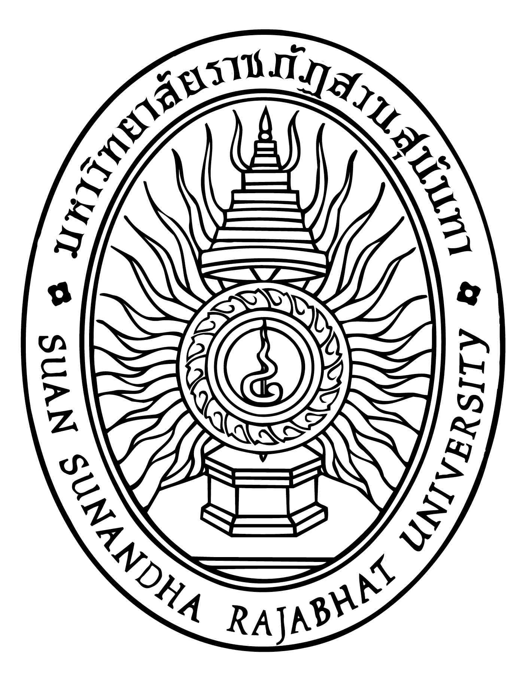

Research Report

Muay Thai and It’s Transition to International Level

By

Mr.Mohamed Darma Khairiree

Research Granted from
Suan Sunandha Rajabhat University
Fiscal Year 2017

